|  |
| --- |
| **Crystal Rock - Quartz** |

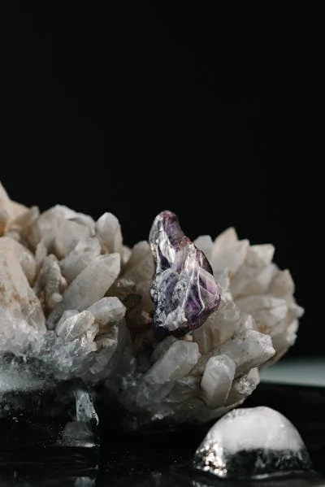

Quartz is one of the most abundant and widely distributed minerals on Earth. It's a vital component of many rocks, and it has a wide range of forms and colors. Here's a detailed look at **Quartz** and its crystal rock form: